PROJECT TITLE:

CROP HEALTH ASSISTANT

**ASSISTED BY:**

Anil kumar

Swati rao

Lalitha Gayathri

**BONAFIED WORK DONE BY:**

Rishitha B.

Sowmyashree H.

Sushma M.

**INTRODUCTION:**

The most common answer that one expects is “to make computers intelligent so that they can act intelligently!”, but the question is how much intelligent? How can one judge the intelligence?

…as intelligent as humans. If the computers can, somehow, solve real-world problems, by improving on their own from the past experiences, they would be called “intelligent”.  
Thus, the AI systems are more generic (rather than specific), have the ability to “think” and are more flexible.

Applications of AI include Natural Language Processing, Gaming, Speech Recognition, Vision Systems, Healthcare, Automotive etc

We use Python because Python programs can be close to pseudo-code. It is designed for humans to read. Python is reasonably efficient. This will result in much less programming and more efficient code (because you will have more time to optimize) than writing everything in a low-level language

So basically we are using Convolution Neural Network process in our project.

A Convolutional Neural Network (CNN) is a specific type of artificial neural network that uses perceptions, a machine learning unit algorithm, for supervised learning, to analyze data. CNNs apply to image processing, natural language processing and other kinds of cognitive tasks.

**MAIN OBJECTIVE:**

CROP HEALTH ASSISTANT, the main objective that we are focusing on analysis and predicting the crops health conditions. Providing remedies based on the symptoms of a disease using chat bot i.e., through communication with research centres

**PROBLEM STATEMENT**:

If we consider this as real time application, using drones to take pictures of crop might be a lot easier .Creating a dataset of pictures, analysis and predicting the disease of crop by using CNN model and image processing.

**Review of literature:**

Artificial Intelligence (AI) can be applied cross disciplinary and it can also bring a paradigm

shift in how we see farming today. AI-powered solutions will not only enable farmers to do

more with less, it will also improve quality and ensure faster go-to-market for crops.

Artificial Intelligence (AI) can be applied cross disciplinary and it can also bring a paradigm

shift in how we see farming today. AI-powered solutions will not only enable farmers to do

more with less, it will also improve quality and ensure faster go-to-market for crops.

Artificial Intelligence (AI) can be applied cross disciplinary and it can also bring a paradigm

shift in how we see farming today. AI-powered solutions will not only enable farmers to do

more with less, it will also improve quality and ensure faster go-to-market for crops.

Artificial Intelligence can be applied across disciplinary and it can also bring paradigm shift is how we see farming today .AI powered solution will not only enable farmers to do more with less, it will also improve quality and ensure faster go to market for crops. Existing technology using AI are chatbot based technology, image processing etc.

**Data collection:**

The dataset comprising of Leaf Data, The crop we consider in our model is Rice The attributes considered where general types of diseases in Leaf.

**Methodology :**

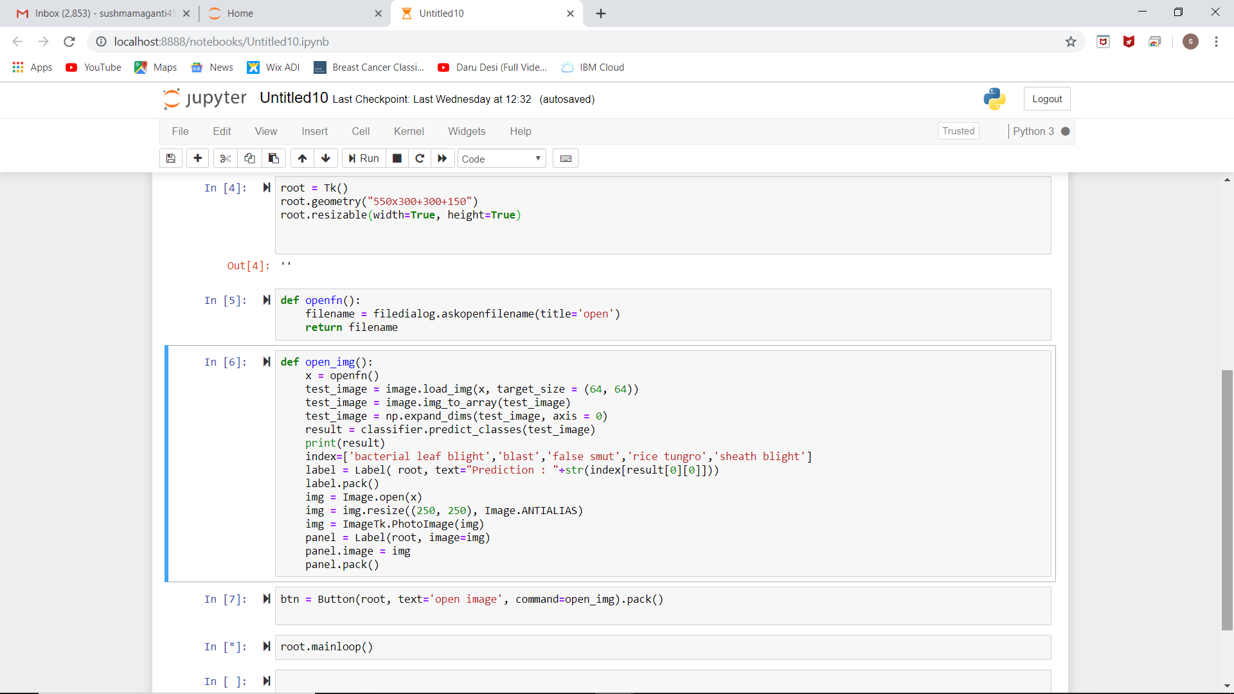

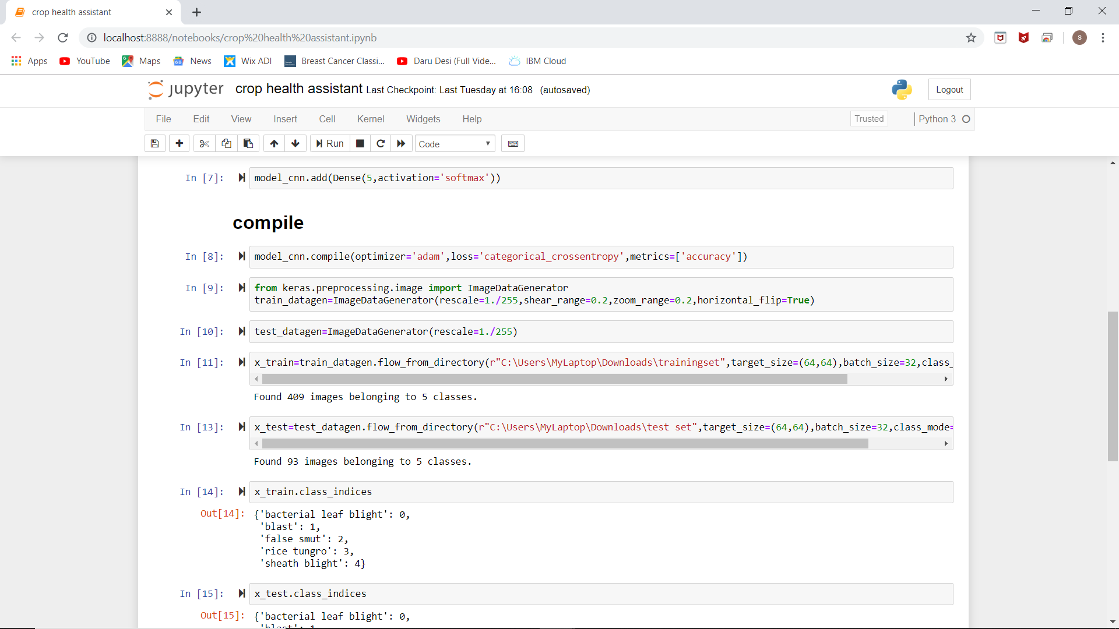

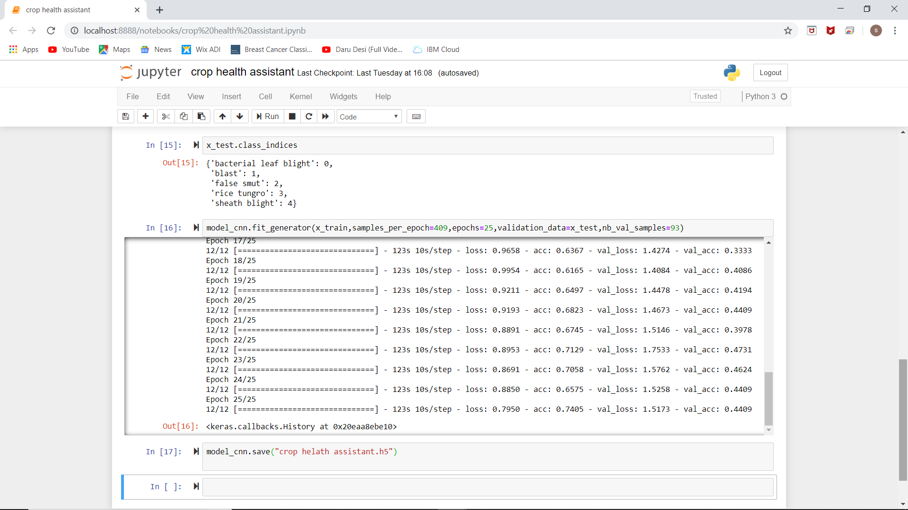

**Data modeling:**

We used many functions to predict the output.

We used the CNN type to solve the situation

Also Softmax Activation Function, which divides the data according to the layers,

**Findings and suggestions:**

Agriculture plays a vital role in our daily lives ,so we wanted to make it easier to farmers to analyse and predict the disease of crop .

We also made sure that if at all a farmer wants to analyse and predict the disease precisely ,he needs a faster and easier communication,that we have done by using chatbot concept.

Everything would be lot more easier if the farmer is bit educated,so that we can focus on parameters like Tempature,Humidity,pH level of soil to suggest remedies precisely.

**Conclusion:**

India is a Nation in which the Agriculture plays a prime role ,In prosperity of the farmers , prospers the Nation .Thus our work would help them and acquire good yielding profit out of such a technique,increases the overall productivity of the nation Our future work is aimed on improved Dataset with large number of attributes also implements the yield prediction.

increasing the overall productivity of the nation. Our

future work is aimed at an improved data set with large

number of attributes and also implements yield

India is a nation in which agriculture plays a prime role.

In prosperity of the farmers, prospers the nation. Thus our

work would help farmers in sowing the right seed based

**The rules induced from the random tree model and CHAID**

**model are shown in the figure 6, 7 respectively. The rules**

**are generated in form of if-then rules where the then part**

**specifies the class label. The classification of every**

**training set is precisely shown.**

**The rules (figure 7, 8) generated from the above model is**

**used to develop a RECOMMENDATION SYSTEM. This is**

**achieved by creating a GUI. The GUI (figure 8) is deployed**

**as a web portal. The model which is trained with the**

**training data set is tested with inputs from the user from the**

**portal. The scripting done will respond to any test case**

**suggesting a crop. If the test case doesn’t match any of the**

**predictions then a no match output is produced**

**The rules induced from the random tree model and CHAID**

**model are shown in the figure 6, 7 respectively. The rules**

**are generated in form of if-then rules where the then part**

**specifies the class label. The classification of every**

**training set is precisely shown.**

**The rules (figure 7, 8) generated from the above model is**

**used to develop a RECOMMENDATION SYSTEM. This is**

**achieved by creating a GUI. The GUI (figure 8) is deployed**

**as a web portal. The model which is trained with the**

**training data set is tested with inputs from the user from the**

**portal. The scripting done will respond to any test case**

**suggesting a crop. If the test case doesn’t match any of the**

**predictions then a no match output is produced**

**The rules induced from the random tree model and CHAID**

**model are shown in the figure 6, 7 respectively. The rules**

**are generated in form of if-then rules where the then part**

**specifies the class label. The classification of every**

**training set is precisely shown.**

**The rules (figure 7, 8) generated from the above model is**

**used to develop a RECOMMENDATION SYSTEM. This is**

**achieved by creating a GUI. The GUI (figure 8) is deployed**

**as a web portal. The model which is trained with the**

**training data set is tested with inputs from the user from the**

**portal. The scripting done will respond to any test case**

**suggesting a crop. If the test case doesn’t match any of the**

**predictions then a no match output is produced**

**The rules induced from the random tree model and CHAID**

**model are shown in the figure 6, 7 respectively. The rules**

**are generated in form of if-then rules where the then part**

**specifies the class label. The classification of every**

**training set is precisely shown.**

**The rules (figure 7, 8) generated from the above model is**

**used to develop a RECOMMENDATION SYSTEM. This is**

**achieved by creating a GUI. The GUI (figure 8) is deployed**

**as a web portal. The model which is trained with the**

**training data set is tested with inputs from the user from the**

**portal. The scripting done will respond to any test case**

**suggesting a crop. If the test case doesn’t match any of the**

**predictions then a no match output is produced**

**The rules induced from the random tree model and CHAID**

**model are shown in the figure 6, 7 respectively. The rules**

**are generated in form of if-then rules where the then part**

**specifies the class label. The classification of every**

**India is a nation in which agriculture plays a prime role.**

**In prosperity of the farmers, prospers the nation. Thus our**

**work would help farmers in sowing the right seed based**

**India is a nation in which agriculture plays a prime role.**

**In prosperity of the farmers, prospers the nation. Thus our**

**work would help farmers in sowing the right seed based**

**India is a nation in which agriculture plays a prime role.**

**In prosperity of the farmers, prospers the nation. Thus our**

**work would help farmers in sowing the right seed based**

Artificial Intelligence (AI) can be applied cross disciplinary and it can also bring a paradigm

shift in how we see farming today. AI-powered solutions will not only enable farmers to do

more with less, it will also improve quality and ensure faster go-to-market for crops.